*Paul Zebarth*

*0524826*

*Daq Final Project*

Computer Acquisition and Control

Table of Contents

Introduction 2

Design Considerations 2

Program Design 3

VI Process 3

Figure 1: LabVIEW VI Block Diagram 4

Circuit Design 5

Circuit Components needed to replicate results 5

Suggested Circuits 5

Figure 2: Low, High, and Notch Filter Schematics 5

DAQ Connections 5

Figure 3: DAQ to Circuit Connections 5

Interface 6

Front Panel 6

Figure 4: VI Front Panel 6

Using the VI 6

Works Cited 7

# Introduction

LabVIEW 2016 was used to develop a Virtual Instrument (VI) using a Data Acquisition (DAQ) card. This VI supplies and sources AC voltage to low pass, high pass, and notch filter circuits chosen from Horowitz and Hill: The Art of Electronics. The VI’s purpose was to take a user defined frequency range and analyze the circuits response over those frequencies. This was done by outputting the waveform of the circuit’s input and output voltage on the same graph with respect to time, in order to compare amplitudes. Furthermore, the response of the circuits, or the ratio of output and input voltage was plotted against the frequency to determine the response of the respective circuit. The circuits had to be designed with consideration of the limitations of the NI PCI-3259 DAQ card, as well as the NI SCC-68 connector device used in building this VI, the available electrical components necessary to build the circuits, and the commands available within LabVIEW.

## Design Considerations

This VI is designed to output a voltage at a user defined frequency, so low, high and notch filter circuits can sweep over their 3 dB frequency values. Using the device specifications of NI 6259, the program can be designed within the limitations of its operation. The relevant information considered in the design is; the analog output impedance of 0.2Ω, the analog input impedance between input and ground (AI+ to AI GND) which is >10GΩ and the output current drive of +/- 5 mA (National Instruments, 2016). In addition, through testing, the analog output maximum frequency was determined to be 50kHz, with smooth sine waves, this VI uses frequencies of $≤$ 20 kHZ.

The frequency was limited by the number of samples the analog output wrote. The number of samples was chosen to be 100, which is enough to create smooth data points over the range of frequencies considered. The limitation is imposed by the loop that the DAQ Assistant is written in. Increasing the samples written requires the iterations to slow down because it increases the amount of data the analog inputs have to read. Within the parameters of the NI PCI-3259 DAQ card, the circuits were designed to be analyzed at an optimal 3dB frequency (approximately 3-7 kHz). However, this VI can be used to analyze circuits up to a 3dB frequency of $<$ 9kHz. When designing a notch filter to analyze using this program, remember to consider the low input impedance, which would result in the voltage source of the DAQ card to be affected by the current change in the circuit. The program shows the ratio of the output and input voltages, and therefore this effect of the change in current is cancelled and not shown.

The program iterates a loop, changing the lower frequency to the upper frequency in steps of 100 Hz. The iteration step size was chosen because the circuits need to be analyzed over a large frequency and a smaller step size is not needed for smooth data plots. The iterations were restricted to every two seconds to allow the VI time to write the analog output samples (voltage sine wave) and read the two input samples (voltage sine wave). You can increase the step size, time delay between iterations, written samples, and read samples manually if computing time is not an issue. The analog output voltage was set at an amplitude of 1V due to the fact that only the ratios matter for analysis. This VI completes the task with sufficient data in reasonable time.

# Program Design

Refer to VI block diagram for complete understanding (Figure 2).

## VI Process

1. The user defines a lower and upper frequency
2. The frequency value is inputted into the “Signal Generator” express VI which generates a 1V amplitude sine wave at the specified frequency in dynamic data
3. The dynamic data flows to the DAQ assistant express VI labelled “Output” which controls the AO 0 analog output (port 22 of SCC-68) and produces the sine wave at the specified frequency with 100 written samples
4. Introduced a time delay of 2 seconds
5. The DAQ assistant labelled “Input” reads 1000 samples from the input voltage (port 68 SCC-68) and output voltage (port 33 SCC-68) and outputs dynamic data to a graph labelled “Input and Output Voltage“ on the front panel with the amplitude on the x and time on the y axis’
6. The dynamic data is taken and concerted to a 2D array and then to a 100x2 matrix so it can be manipulated
7. The matrix elements are split so the input voltage signal is separated from the output voltage signal into two 100x1 matrices
8. The maximum values are taken from the input and output voltage signal matrices for this iteration and then compiled into a 1D array, the arrays are then divided to produce the voltage output over voltage input ratio
9. This data is converted to the dynamic data type and inputted into the y-input on the express VI labelled “Build XY Graph”, the x-input is the iteration frequency which is compiled into a 1D array and converted to the dynamic data type, the graph is built in real time with each iteration a new data point is added and is labelled “Gain vs Frequency” on the front panel
10. The specified frequency is connected to a shift register so the frequency returns to the front of the loop where the incremental step size is added and steps 3-10 repeat until the lower frequency plus the increments equal the upper frequency controlled by a case structure which will output the upper frequency if the lower frequency plus the iteration is larger than the upper frequency
11. Then data for the file written is taken from the iteration values of gain and frequency, compiled into a sting and then outputted to a file

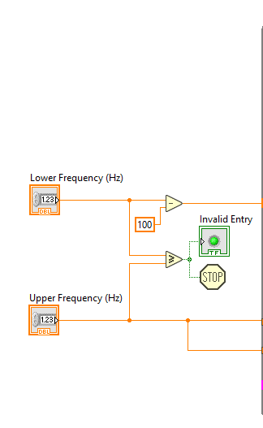

Step 1

Step 2

Step 3

Step 4

Step 5

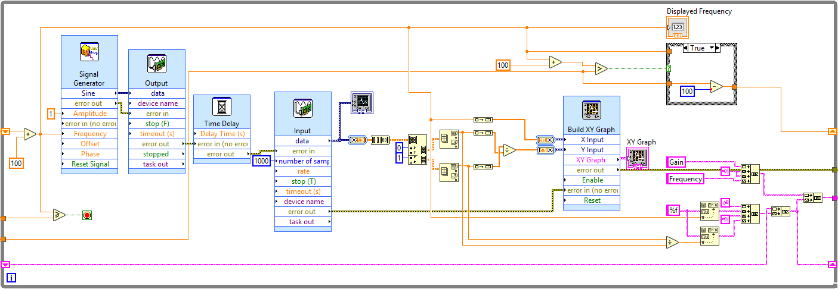

Step 6

Step 7

Step 8

Step 9

Step 11

Step 10

### 

### 

### Figure 1: LabVIEW VI Block Diagram

# Circuit Design

## Circuit Components needed to replicate results

1. 2 X 390 Ω resistors
2. 1 X 100 Ω resistors
3. 2 X 100 μF capacitors
4. 1 X 0.1 H inductor

## Suggested Circuits

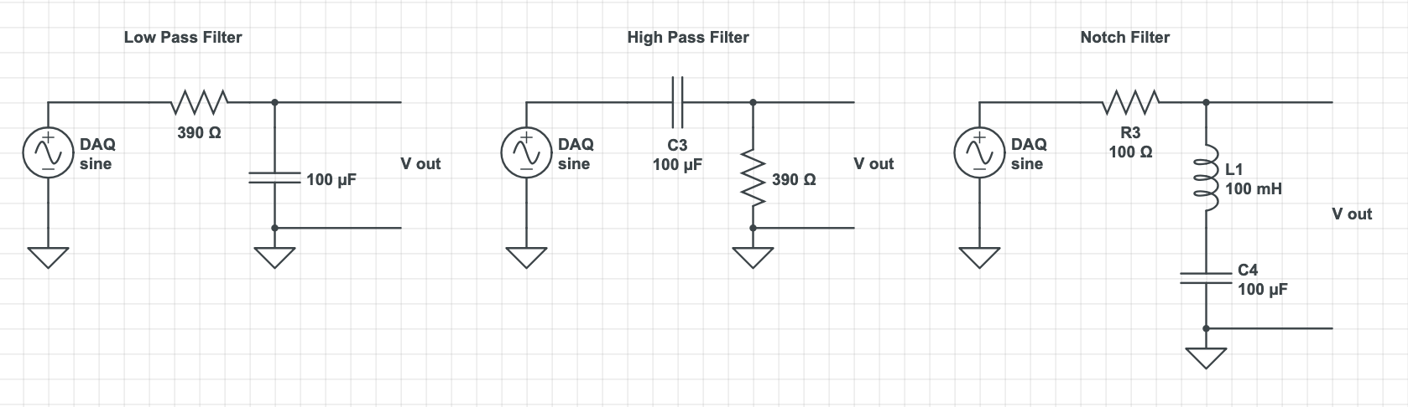

V Out

V In

V Out

V In

V Out

V in

Signal

Signal

Signal

$$f=\frac{1}{2π\sqrt{LC}}≈5kHz$$

$$f=\frac{1}{2πRC}≈4kHz$$

$$f=\frac{1}{2πRC}≈4kHz$$

### Figure 2: Low, High, and Notch Filter Schematics

## DAQ Connections

V Out

V In

Signal

Ground

(National Instruments, 2006)

### Figure 3: DAQ to Circuit Connections

The circuit must be setup up with these connections for the VI to work properly, reference Fig. 2 and Fig. 3 before running VI.

# Interface

## Front Panel

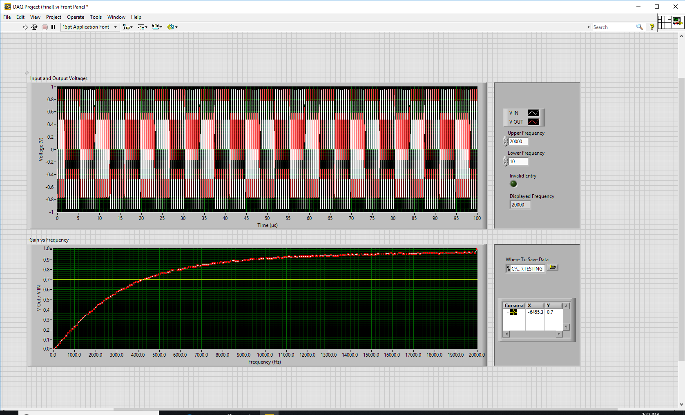

Cursor Table

File name and path directory to save file

User Defined Frequencies

### Figure 4: VI Front Panel

## Using the VI

1. Define an upper frequency less than 20000 Hz and greater than the lower frequency
2. Define a lower frequency less than 19000 Hz and less that the upper frequency
3. Choose a file name and path directory to save your file
4. Run the VI
5. User option to use cursor to retrieve values from gathered data, simply use your mouse to drag cursor around the graph, values are outputted to cursor table
6. A dialog box will open and ask if you want to save your file
7. Repeat steps 1-5 with different file names for different circuits

# Works Cited

Horowitz & Hill. (1989). *The Art of Electronics.* Cambridge: Cambridge University Press.

National Instruments. (2006). *User Guide SCC-68.* Austin, Texas.

National Instruments. (2016). *Device Specifications NI 6259 M Series.* Austin, Texas.